Xbox Third-Party Peripherals Requirements Specification

Published by 8/23/01
Xbox Third-Party Peripherals Team
Microsoft Corporation
One Microsoft Way
Redmond, WA 98052-6399
xbox3pp@xbox.com
Copyright Notice
Xbox is a trademark of Microsoft Corporation.
This documentation is an early release of the final documentation, which may be changed substantially prior to final commercial release, and is confidential and proprietary information of Microsoft Corporation. It is disclosed pursuant to a non-disclosure agreement between the recipient and Microsoft. This document is provided for informational purposes only and Microsoft makes no warranties, either express or implied, in this document. Information in this document, including URL and other Internet Web site references, is subject to change without notice. The entire risk of the use or the results of the use of this document remains with the user. Unless otherwise noted, the example companies, organizations, products, people and events depicted herein are fictitious and no association with any real company, organization, product, person or event is intended or should be inferred. Complying with all applicable copyright laws is the responsibility of the user. Without limiting the rights under copyright, no part of this document may be reproduced, stored in or introduced into a retrieval system, or transmitted in any form or by any means (electronic, mechanical, photocopying, recording, or otherwise), or for any purpose, without the express written permission of Microsoft Corporation.
Microsoft may have patents, patent applications, trademarks, copyrights, or other intellectual property rights covering subject matter in this document. Except as expressly provided in any written license agreement from Microsoft, the furnishing of this document does not give you any license to these patents, trademarks, copyrights, or other intellectual property.
Unpublished work. © 2001 Microsoft Corporation. All rights reserved.
Microsoft and Xbox are either registered trademarks or trademarks of Microsoft Corporation in the United States and/or other countries.

General Description
Product Description
The Xbox™ video game system from Microsoft is a game console with advanced graphics acceleration capability plus a hard disk and a DVD drive built-in. The target market for Xbox is the console game player market in which the console resides in the living room or bedroom, not in the office or den.
The Xbox console has four proprietary USB-based ports on the front to which controllers can be connected. Gamepads are compound controller/input devices, containing all gamepad functions (buttons, thumbsticks, triggers), plus a three-port USB hub. Inside the gamepad, the gamepad function is connected to port one of the downstream hub, while the other two ports are exposed to two module slots accessible to the user. The endpoints for the hub and device function are separate. The downstream module slots are designed to allow any of several planned modules to be connected.
The standard Xbox game controller is a console game input device held in two hands. It features the following components:
- Six action buttons offering eight-bit proportional (analog) control
- Two travel-based proportional (analog) triggers (eight-bit resolution)
- Two vibration feedback motors, one for low frequency forces, one for high frequency forces
- Two analog thumbsticks with integral momentary switches
- One eight-way directional pad
- Two menu navigation buttons (Back and Start)
- Two module expansion slots
- Xbox proprietary plug interface
- Inline quick release connector
The Xbox game controller will support the following modules:
- Memory unit—8-MB memory unit module; 16-MB option TBD.
- Audio unit (future) —headset with headphones and voice command microphone for online gaming.
- Light gun (future)—light gun; supported by the vertical blanking interrupt (VBI) signal. Light gun must be a full speed USB device that reports its position in its own USB packet.
- Tilt module (future) – sense the orientation of the controller in the X-Y-Z axis and allow user better immersion into some games
Controller Configuration

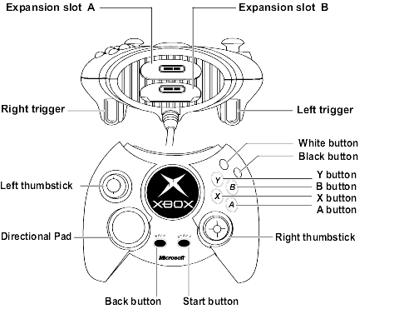
General Specification
Feature Requirements
Feature Reference Number | Feature  Parameter | Full Function Gamepad Requirement | Compatible Gamepad  Min Requirement | Compatible Custom Controller Min Requirement  (MS approval required)
 | Module slots | 2 USB/VBI ports with proprietary connector (Hub + 3 downstream ports) | 1 USB/VBI ports minimum (Hub + 2 downstream ports) | Optional*  (1 USBVBI port minimum is preferred)
 | Vibration feedback | 1 high frequency motor and 1 low frequency motor (per vibration specification) | Optional* | Optional*
 | Thumbsticks | 2 X/Y analog thumbsticks w/tact switches actuated when pressed down  7 bit (128 counts minimum) | 2 X/Y analog thumbsticks w/tact switches actuated when pressed down  7 bit (128 counts minimum) | Optional*
 | Action buttons  (A/B/X/Y, BLK/WHT) | 6 proportional analog 6-8 bit (64 counts minimum) (color and layout per spec) | 6 proportional analog 6-8 bit (64 counts minimum) (color and layout per spec) | Optional*  (minimum A/B required)
 | Triggers | left and right analog  6-8 bit (64 counts minimum) | left and right analog  6-8 bit (64 counts minimum) | Optional*
 | Directional pad | 8 way, digital direction pad | 8 way, digital direction pad | 8 way, digital direction pad
 | Menu navigation buttons | ‘START’ and ‘BACK’ digital buttons | ‘START’ and ‘BACK’ digital buttons | ‘START’ and ‘BACK’ digital buttons
 | Inline quick release connector | Inline connector required | Inline connector required | Inline connector required
 | XBox interface | XBox Full Speed Universal Serial Bus with proprietary connector | XBox Full Speed Universal Serial Bus with proprietary connector | XBox Full Speed Universal Serial Bus with proprietary connector
* Optional features must meet full function requirements if used
Xbox Interface
Xbox Exceptions to the Full Speed USB 1.1 Specification
- No low speed device USB support
- No suspend/resume support
- No port power switching to downstream ports
- Power budget (see current budget table below)
- Connector interface to Xbox is proprietary
- Connector from controller to modules is proprietary
USB Device Function
- Proprietary XID class device; see Xbox Input Device (XID) specification
- one control end point
- one interrupt in endpoint
- one interrupt out endpoint
USB Hub Function
- one control end point
- one interrupt IN endpoint
- downstream port 1: internally attached to gamepad function
- downstream port 2: primary module slot
- downstream port 3: secondary module slot
USB Enumeration of Downstream Slots
- For top/bottom orientation: the top slot is primary; bottom slot is secondary
- If module slots have left/right orientation (while holding the controller), left slot is primary and right slot is secondary.
Power Budget

Device | DC Current | Inrush Current limit | Controller module slot compatibility
xBox Downstream port : | 500mA max | 120uF, 100mA max | na
Gamepad plus hub: | 352mA max | 10uF, TBD | na
High Powered device (upper slot) | 88mA | 10uF, TBD | Mechanically keyed to fit in Slot 1 only
Low Powered device (lower slot) | 60mA max | 10uF, TBD | Slot 1, Slot 2, or both

Xbox System Compatibility
See Xbox Peripheral Compatibility Test List document (xds.xbox.com Peripherals directory) for full details of compatibility testing.
Gamepad Characteristics
Vibration Feedback Characteristics
Parameter | Recommended
Low frequency motor max speed (rpm) | 1600
Low frequency motor min speed (rpm) | 500
Low frequency motor weight | 10.2+/-0.4g
High frequency motor maximum speed (rpm) | 3900
High frequency motor minimum speed (rpm) | 1600
High frequency motor weight | 2.0+/-0.15g
Speed resolution | 8 bit PWM counter
Motor spin up (0 to max) | 50 ms to 60 ms
Motor spin down (max to 0) | 70 ms to 80 ms
Left motor | Low frequency
Right motor | High frequency
Proportional Input Characteristics (Thumbsticks)
Parameter | Requirement
Position resolution | 6-8 bit, 256 steps across full range of motion both physical and logical (128 discrete steps min)
Maximum latency | 5 milliseconds
Logical center position | X=0 counts, Y=0 counts +/- 0 counts
Center position deadband | ± 10% of full scale range (-6554 to +6554)
Jitter | +/- 1 descrete step at any position
Proportional Action Buttons: A, B, X, Y, Black, White
Parameter | Requirement
Position resolution | 6-8 bit, 256 steps across full range of motion (64 discrete steps min)
Maximum latency | 5 milliseconds
Button crosstalk | No crosstalk between buttons when depressed
Layout | Default layout – see picture below  Optional layout - default in Japan region

Action Button Colors: | Requests for color chip samples will be managed through GE ColorXpress (www.gecolorxpress.com). Contact xbox3pp@xbox.com for access ID.

Document No. | Color Name | Used on | Notes | Development Ref. Std.
D00020 | Button Blue | "X" | Transparent | PMS T215-1-3
D00021 | Button Red | "B" | Transparent | PMS T075-2-1
D00022 | Button Green | "A" | Transparent | PMS T325-2-1
D00024 | Button Yellow | "Y" | Transparent | PMS T045-2-3
Dxxxxx | Opaque Blue | "X" | Under Dev | PMS 2728C
Dxxxxx | Opaque Red | "B" | Under Dev | PMS 1797C
Dxxxxx | Opaque Green | "A" | Under Dev | PMS 377C
Dxxxxx | Opaque Yellow | "Y" | Under Dev | PMS 116C

Action button default layout sample: 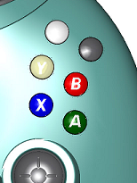

Action button alternate layout sample: 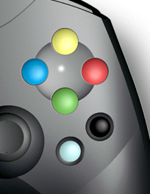
Proportional Triggers; Left and Right
Parameter | Requirement
Position resolution | 6-8 bit, 256 steps across full range of motion (64 discrete steps min)
Maximum latency | 5 milliseconds
Eight-Way Discrete Directional Pad
Parameter | Requirement
Switches | 8 way, digital
Maximum latency | 5 milliseconds
Menu Navigation Buttons (Back and Start)
Parameter | Requirement
Switches | Digital
Maximum latency | 5 milliseconds
Module slots
Module Slot Pin-out
Pin # | Slot #1 | Slot #2 | Description
Pin1 | VCC | VCC | + 5V DC
Pin2 | DMR2 | DMR3 | USB D-
Pin3 | DPR2 | DPR3 | USB D+
Pin4 | VBI | VBI | Vertical blanking interval
Pin5 | GND | GND | Ground
Insertion Force Removal Force
2.25 lbs. 0.45 lbsModule Slot Size
Refer to reference CAD ProE files for full slot and module design details (provided in xds.xbox.com Peripheral directory, see “dock and MU” files) and keep out areas (see “slot area” file).
Note: lower slot has keying to prevent high power module insertion.
13.5 mm high, 40 mm wide, 25mm deep16 mm (center-center) stack height

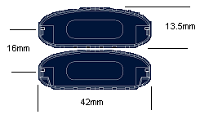
Xbox Interface Cable
Description: 3-meter shielded cable with 5-pin proprietary Xbox connector
Pin1: VCC
Pin2: D- [twisted pair with D+]
Pin3: D+ [twisted pair with D-]
Pin4: VBI
Pin5: ground
Shield: drain
Meets functional requirements of USB 1.1 revision specifications
In-line Disconnect Connector
Parameter | Requirement
In-line disconnect connector | 2.75 ± 1.25 lb. force, located 9.5” ± 1” from console connector edge to disconnect break point. (Detail spec to be provided.)
Custom Controller Key Mapping Defaults
The tables below list the default key mapping from controls on custom devices to the controls as specified on the standard Xbox Controller. Refer to the Xbox XID spec for subclass definitions.

Wheel Key Mapping Defaults

Driving/Racing Game Function | Xbox Controller | Wheel Feature Requirements
Accelerate | Right Trigger | Accelerate
Brake | Left Trigger | Brake
Steering | L-Thumbstick Left/Right | Wheel
Optional | L-Thumbstick Up/Down | Not Used
Optional | R-Thumbstick Left/Right | Optional
Optional | R-Thumbstick Up/Down | Optional
Optional | D-Pad Up/Down | D-Pad Up/Down
Steering | D-Pad Left/Right | D-Pad Left/Right
Gear Down | A | A
Hand Brake | B | B
Gear Up | X | X
Change Camera | Y | Y
Optional | Black | Black
Optional | White | White
Optional | Left Thumbstick-button | Optional
Optional | Right Thumbstick-button | Optional
Pause | Start | Start
Back | Back | Back

Arcade Stick Key Mapping Defaults

Xbox Controller | Arcade Stick  Feature Requirements
Right Trigger | T1
Left Trigger | T2
L-Thumbstick Left/Right | Not Used
L-Thumbstick Up/Down | Not Used
R-Thumbstick Left/Right | Not Used
R-Thumbstick Up/Down | Not Used
D-Pad Up/Down | Stick Up/Down
D-Pad Left/Right | Stick Left/Right
A | A (green)
B | B (red)
X | X (blue)
Y | Y (yellow)
Black | Black
White | White
Left Thumbstick-button | Optional
Right Thumbstick-button | Optional
Start | Start*
Back | Back*
* Layout location optional

Recommended button layout:

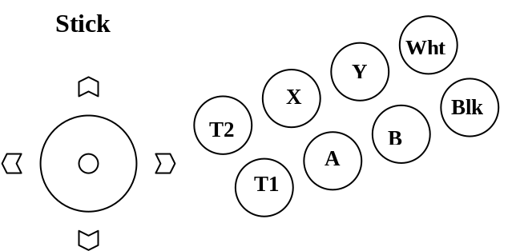

Flight Stick Key Mapping Defaults

Flight  Game Function | Xbox Controller | Flight Stick  Feature Requirements
Accelerate | Right Trigger | Throttle up
Brake | Left Trigger | Throttle down
Roll Left/Right | L-Thumbstick Left/Right | Stick X axis
Pitch Up/Down | L-Thumbstick Up/Down | Stick Y axis
Rudder Left/Right | R-Thumbstick Left/Right | Twisting handle
Optional | R-Thumbstick Up/Down | Not Used
POV (views) | D-Pad Up/Down | D-Pad Up/Down
POV (views) | D-Pad Left/Right | D-Pad Left/Right
Primary Weapon | A | A (stick trigger)
Secondary Weapon | B | B
Action | X | X
Action | Y | Y
Optional | Black | Black
Optional | White | White
Optional | Left Thumbstick-button | Optional
Optional | Right Thumbstick-button | Optional
Pause | Start | Start
Back | Back | Back

Snow/Skate Board Key Mapping Defaults

Board Game Function | Xbox Controller | Hardware Board Feature Requirements
Spin right | Right Trigger | Right trigger
Spin left | Left Trigger | Left trigger
Steer left/right | L-Thumbstick Left/Right | Left/right board pitch
Lean forward/back | L-Thumbstick Up/Down | Front button on board lean forward  Rear button on board lean backward
Optional | R-Thumbstick Up/Down | R-Stick up/down
Optional | R-Thumbstick Left/Right | R-Stick left/right
Lean forward/back | D-Pad Up/Down | D-Pad Up/Down
Steer left/right | D-Pad Left/Right | D-Pad Left/Right
Trick | A | A
Trick | B | B
Trick | X | X
Trick | Y | Y
Optional | Black | Black
Optional | White | White
Optional | Left Thumbstick-button | Not Used
Optional | Right Thumbstick-button | Right thumb-button
Pause | Start | Start
Back | Back | Back

Minimum Host System Requirements and Software
Host System Requirements
Parameter | Requirement
Host computer | Xbox only
System software | Xbox system software only
Port | Xbox proprietary full speed USB port
Software Requirements
See Xbox Input Device (XID) Specification

Compatibility Testing
Xbox Peripheral Compatibility Verification
Compatibility verification testing consists of six steps:
- Check list completion
- Electrical testing
- Signal testing
- Protocol testing
- Mechanical verification
- Gameplay testing
Full details on testing requirements can be found on the NTS Web site: www.ntscorp.com/xboxtesting/.
Xbox Peripheral Compatibility Verification Test Center
Contact NTS for access to the Web site and test scheduling and results:
Bill Schoneman
VP Sales and Marketing
bills@ntslabs.com
NTS Testing Laboratories
5730 Buckingham Parkway
Culver City, CA 90230
1.800.879.9225
www.ntscorp.com/xboxtesting/

